MTF Research Summary
Thomas Nikolai, Eric J. Galbraith, Michael P. Rabe
Michigan State University
February 2026

Project Name: No-Mow May 2025

How the MTF funding will be used to support project(s): Support funding will allow researchers to evaluate the effects of the “No-Mow May” trend. How does allowing a typical home lawn to grow unimpeded for the month of May compare to a lawn mown on a regular schedule? We wanted to look at percent weeds during and after May, as well as differences in turf quality after May when the longer turf was finally mowed.

Methods: This trial began in early May 2025. Mower Height of Cut was set to 3.5”. Control plots were mowed twice a week throughout the trial period. No-mow plots were left to grow during May and began the same mow schedule as the control plots on June 2nd. No-mow plots had reached an average height of 6.75” by the first mow on June 2nd.
Project update: The mowing on June 2nd stunted the turfgrass and weeds in no-mow plots leading to a decrease in turf quality and percent weeds. Clippings were left on plots to mimic typical home lawn conditions. We saw momentary decreases in weed populations in no-mow plots due to the stunting effect, but weed populations eventually sprang back to levels similar to mowed plots by early August.
Fewer weeds in no-mow plots due to the combination of higher turf height during May followed by a shock effect from the June mowing was accompanied by significant decreases in turf quality. Turf quality on no-mow plots was poor throughout June, and began to level out by the end of the month.
Table 1. Percent Dandelions 2025
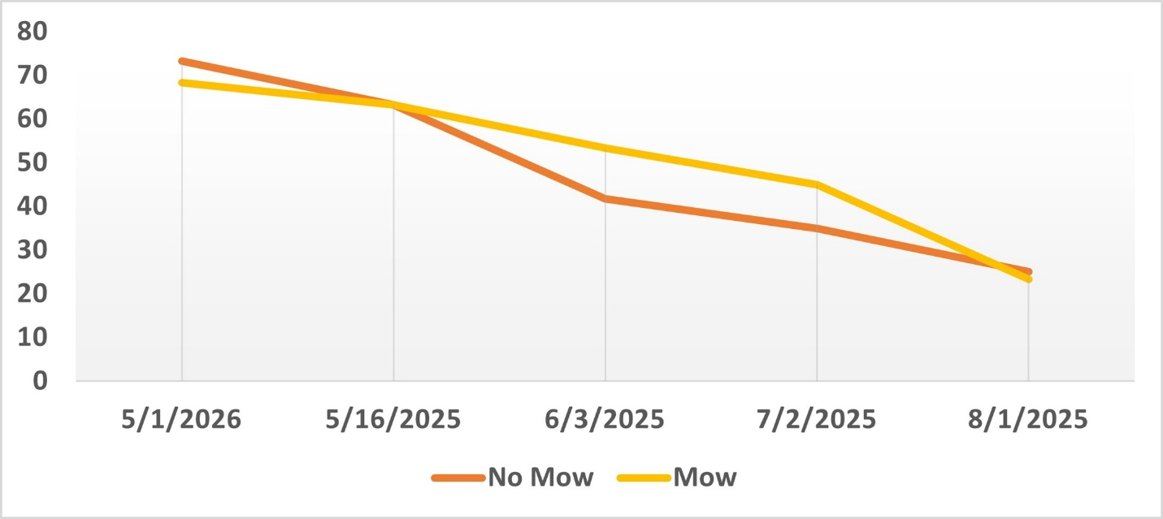
Table 2. Percent Clover 2025
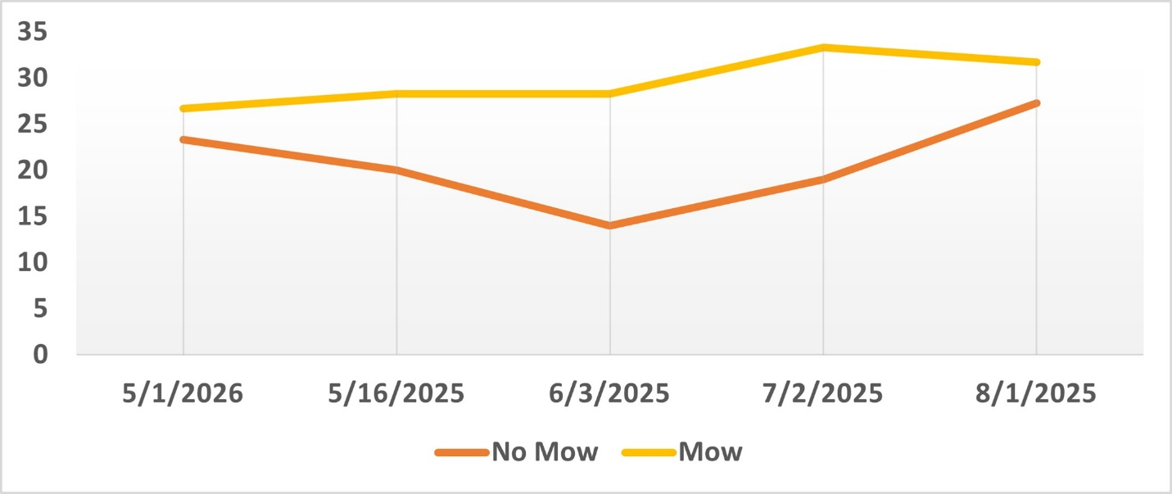
Table 3. Percent Plantain 2025
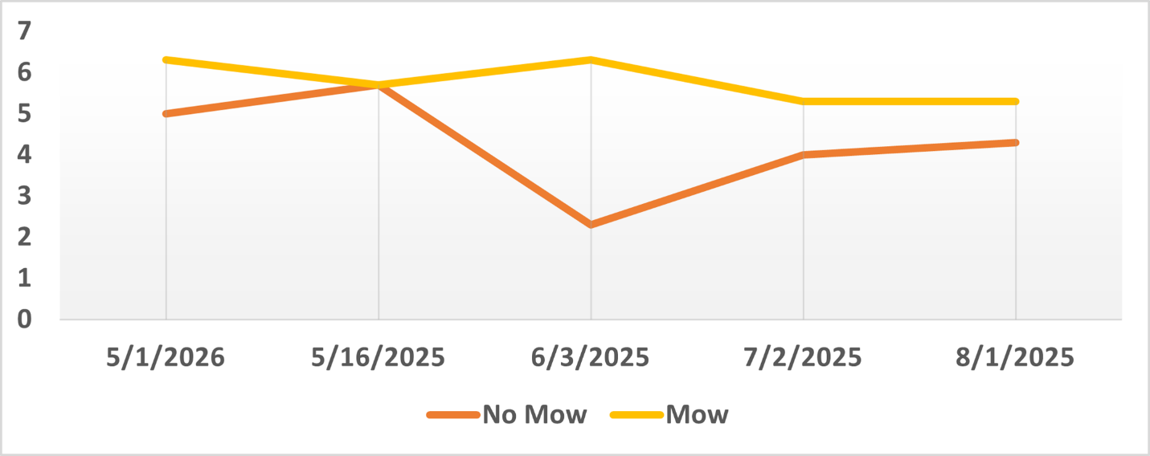
Table 4. Post-Mow Quality Ratings 2025
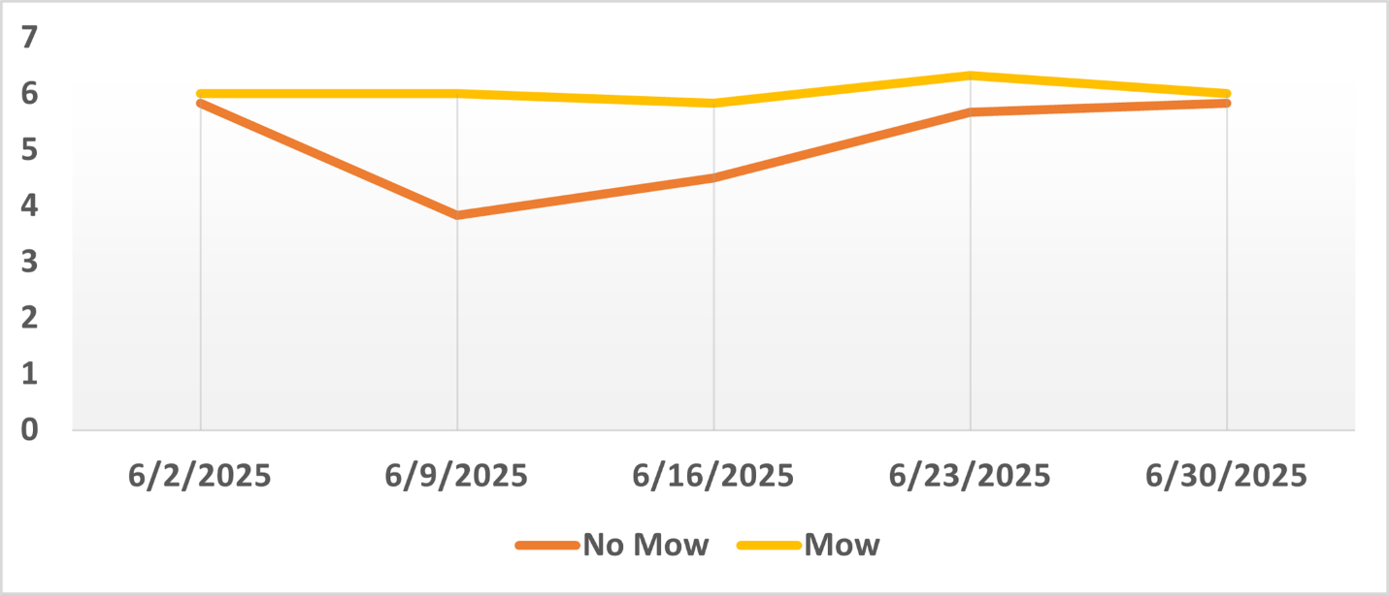

Grad Student(s) Involved: Michael Rabe

Benefit Group: This research will primarily benefit the home lawn industry. There is always debate on the effects that new lawn care trends have on the health of the turf and this research helps to answer some of those questions. After analyzing the results from this trial, home lawn owners can ask themselves if potential momentary decreases in visual weeds are worth the significant decrease in turf quality during the month of June.

Project Images:
Figure 1. May 7, 2025 (1 week un-mowed)
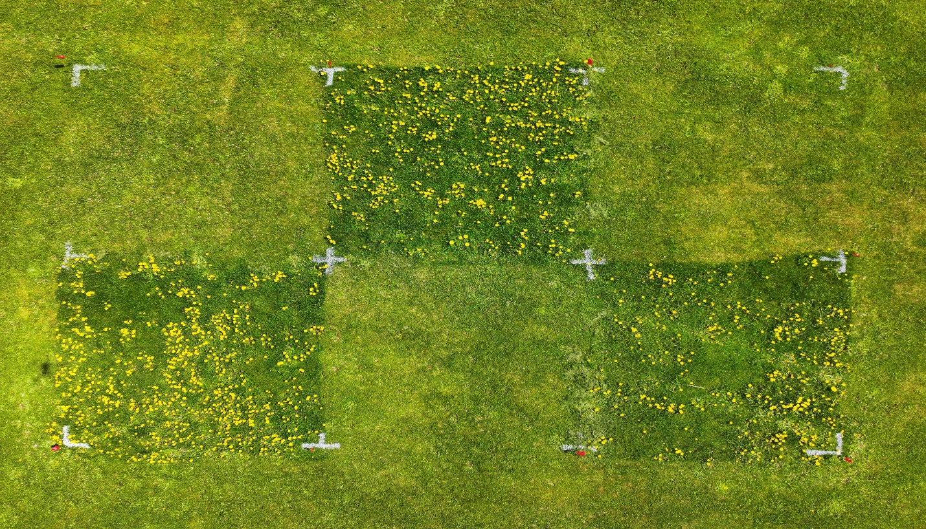
Figure 2. June 2, 2025 (1 month un-mowed)
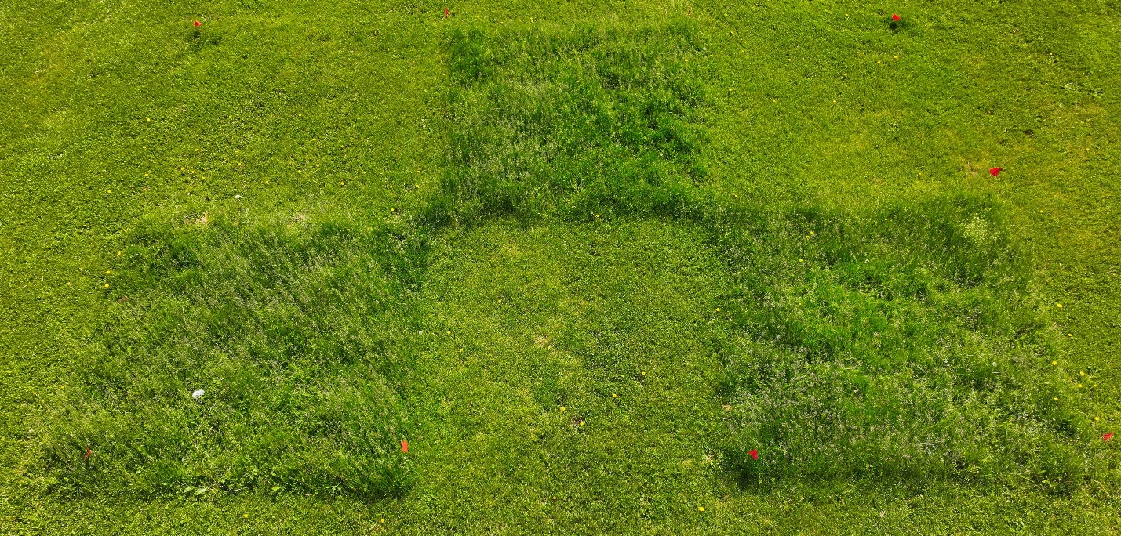
Figure 3. June 2, 2025 (Post-Mow)
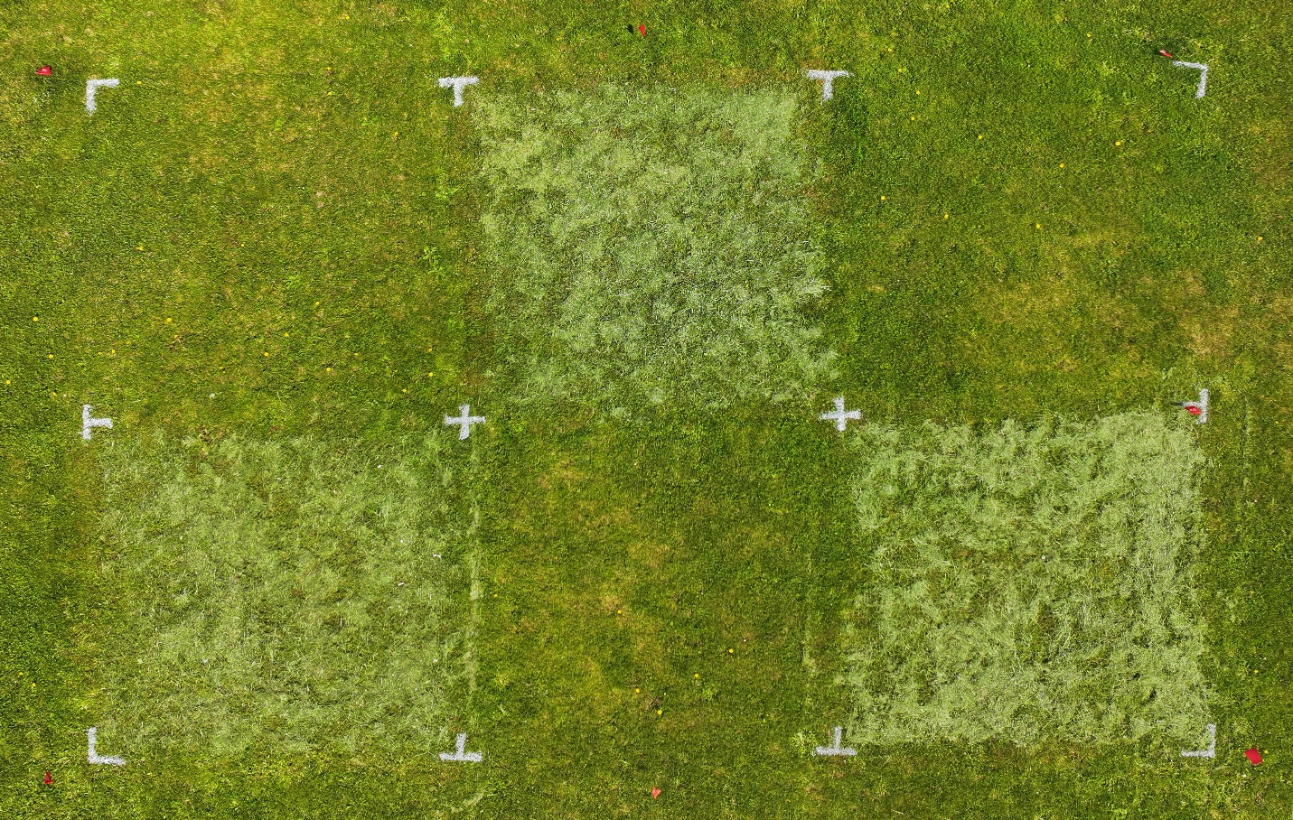
Figure 4. June 12, 2025 (10 days post-mow)
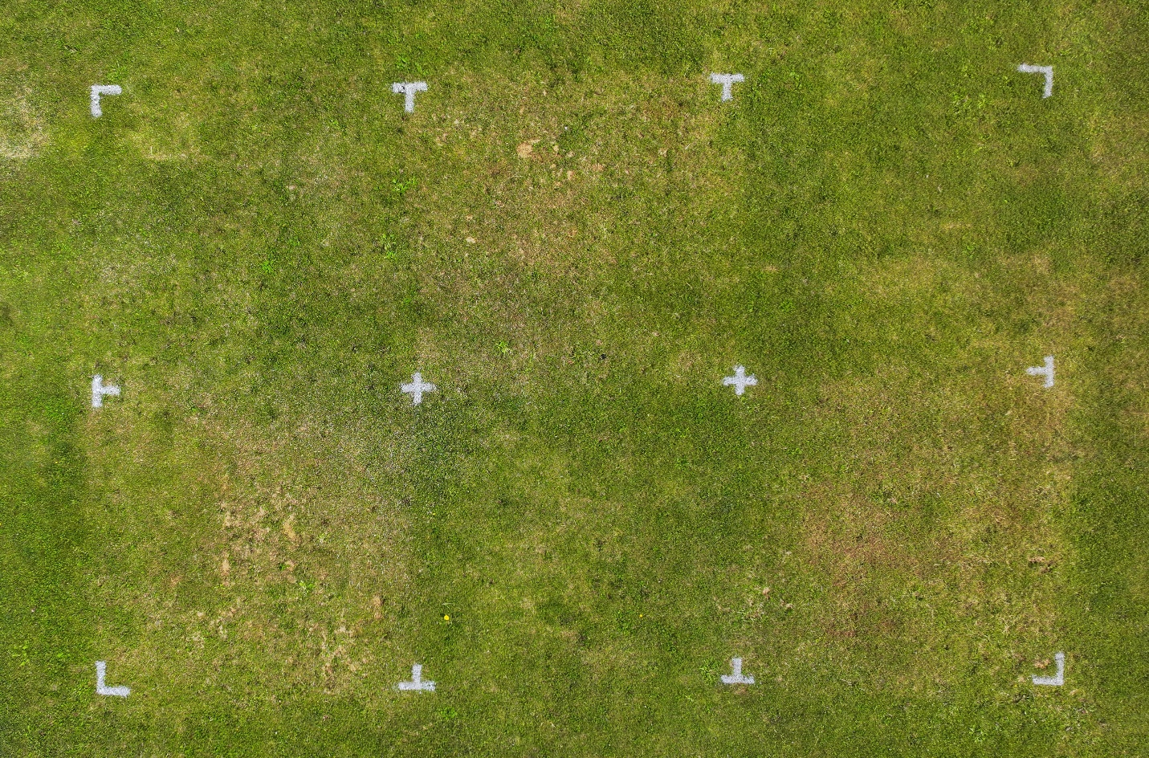
Figure 5. June 25, 2025 (3 weeks post-mow)
